**Network Types**

The size of a network should be expressed by the geographic area and number of computers, which are a part of their networks. It includes devices housed in a single room to millions of devices spread across the world.

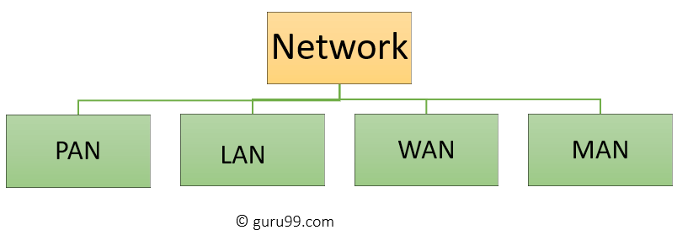

## **What is PAN (Personal Area Network)?**

PAN is a computer network formed around a person. It generally consists of a computer, mobile, or personal digital assistant. PAN can be used for establishing communication among these personal devices for connecting to a digital network and the internet.

### **Characteristics of PAN**

* It is mostly personal devices network equipped within a limited area.
* Allows you to handle the interconnection of IT devices at the surrounding of a single user.
* PAN includes mobile devices, tablet, and laptop.
* It can be wirelessly connected to the internet called WPAN.
* Appliances use for PAN: cordless mice, keyboards, and Bluetooth systems.

### **Advantages of PAN**

Here, are important pros/benefits of using PAN network:

* PAN networks are relatively secure and safe
* It offers only short-range solution up to ten meters
* Strictly restricted to a small area

### **Disadvantages of PAN**

Here are important cons/ drawback of using PAN network:

* It may establish a bad connection to other networks at the same radio bands.
* Distance limits.

## **What is LAN?**

[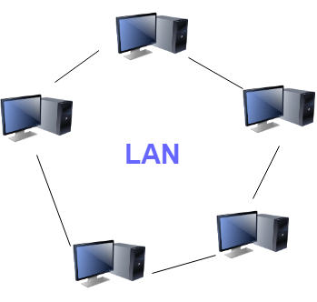](https://www.guru99.com/images/1/090719_0501_TypesofComp2.png)

A ****L****ocal ****A****rea ****N****etwork (LAN) is a group of computer and peripheral devices which are connected in a limited area such as school, laboratory, home, and office building. It is a widely useful network for sharing resources like files, printers, games, and other application. The simplest type of LAN network is to connect computers and a printer in someone's home or office. In general, LAN will be used as one type of transmission medium.

It is a network which consists of less than 5000 interconnected devices across several buildings.

### **Characteristics of LAN**

Here are important characteristics of a LAN network:

* It is a private network, so an outside regulatory body never controls it.
* LAN operates at a relatively higher speed compared to other WAN systems.
* There are various kinds of media access control methods like token ring and ethernet.

### **Advantages of LAN**

Here are pros/benefits of using LAN:

* Computer resources like hard-disks, DVD-ROM, and printers can share local area networks. This significantly reduces the cost of hardware purchases.
* You can use the same software over the network instead of purchasing the licensed software for each client in the network.
* Data of all network users can be stored on a single hard disk of the server computer.
* You can easily transfer data and messages over networked computers.
* It will be easy to manage data at only one place, which makes data more secure.
* Local Area Network offers the facility to share a single internet connection among all the LAN users.

### **Disadvantages of LAN**

Here are the important cons/ drawbacks of LAN:-

* LAN will indeed save cost because of shared computer resources, but the initial cost of installing Local Area Networks is quite high.
* The LAN admin can check personal data files of every LAN user, so it does not offer good privacy.
* Unauthorized users can access critical data of an organization in case LAN admin is not able to secure centralized data repository.
* Local Area Network requires a constant LAN administration as there are issues related to software setup and hardware failures

## **What is WAN?**

[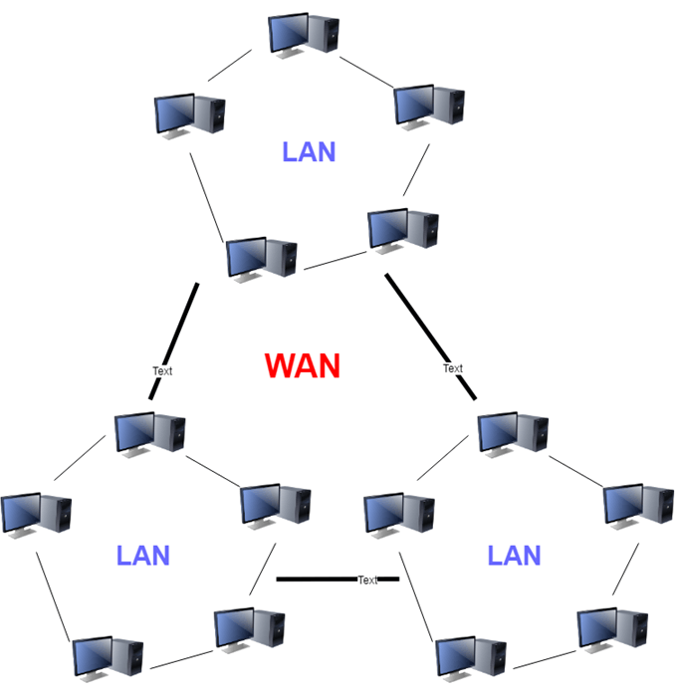](https://www.guru99.com/images/1/090719_0501_TypesofComp3.png)

WAN (Wide Area Network) is another important computer network that which is spread across a large geographical area. WAN network system could be a connection of a LAN which connects with other LAN's using telephone lines and radio waves. It is mostly limited to an enterprise or an organization.

### **Characteristics of LAN:**

* The software files will be shared among all the users; therefore, all can access to the latest files.
* Any organization can form its global integrated network using WAN.

### **Advantages of WAN**

Here are the benefits/ pros of using WAN:

* WAN helps you to cover a larger geographical area. Therefore business offices situated at longer distances can easily communicate.
* Contains devices like mobile phones, laptop, tablet, computers, gaming consoles, etc.
* WLAN connections work using radio transmitters and receivers built into client devices.

### **Disadvantage of WAN**

Here are drawbacks/cons of using WAN:

* The initial setup cost of investment is very high.
* It is difficult to maintain the WAN network. You need skilled technicians and network administrators.
* There are more errors and issues because of the wide coverage and the use of different technologies.
* It requires more time to resolve issues because of the involvement of multiple wired and wireless technologies.
* Offers lower security compared to other types of networks.

## **What is MAN?**

[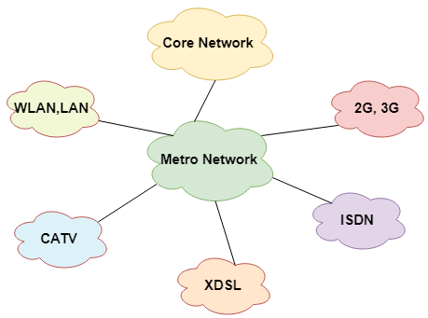](https://www.guru99.com/images/1/090719_0501_TypesofComp4.png)

A Metropolitan Area Network or MAN is consisting of a computer network across an entire city, college campus, or a small region. This type of network is large than a LAN, which is mostly limited to a single building or site. Depending upon the type of configuration, this type of network allows you to cover an area from several miles to tens of miles.

### **Characteristics of MAN**

Here are important characteristics of the MAN network:

* It mostly covers towns and cities in a maximum 50 km range
* Mostly used medium is optical fibers, cables
* Data rates adequate for distributed computing applications.

### **Advantages of MAN**

Here are pros/benefits of using MAN system:

* It offers fast communication using high-speed carriers, like fiber optic cables.
* It provides excellent support for an extensive size network and greater access to WANs.
* The dual bus in MAN network provides support to transmit data in both directions concurrently.
* A MAN network mostly includes some areas of a city or an entire city.

### **Disadvantages of MAN**

Here are drawbacks/ cons of using the MAN network:

* You need more cable to establish MAN connection from one place to another.
* In MAN network it is tough to make the system secure from hackers